**Centroid project**

The goal is to find the Center of Mass (or Centroid) of a two dimensional shape.

For a **point-mass system** (separate and distinct objects), to find the center of mass, you multiply each mass by its distance from the origin and find the sum of all these values. Then you divide by the total of all the masses. Here is a picture that shows a point-mass system in one dimension:

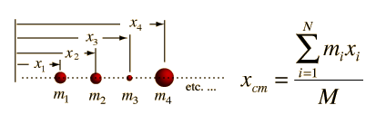

The simplest scenario is finding the center of mass of two objects:

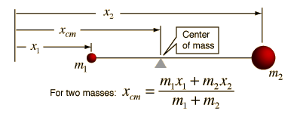

If you have a **continuous object** such as a stick (or rod), then you need to use integration to find the center of mass because you have an infinite number of masses all squished together.

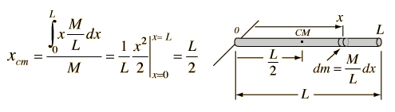

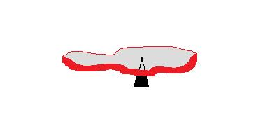In this project, we are going to investigate the center of mass of a **two-dimensional object**, called a **lamina**, so we need to integrate in x AND in y. For an object with constant density, the formulas to find the Center of Mass of a two dimensional objects are as follows:

**Mass: $\int_{a}^{b}{f\left(x\right)-g\left(x\right)dx}$**

**x-coordinate: $\overline{x}=\frac{1}{m}\int_{a}^{b}{x\left[f\left(x\right)-g\left(x\right)\right] dx}$**

**y-coordinate: $\overline{y}=\frac{1}{m}\int_{c}^{d}{y\left[h\left(y\right)-k\left(y\right)\right] dy}$**

**Activity 1: Find the centroid of a pre-cut shape**

**Method 1: Curve Fitting and Integration by hand**

***Step 1***: Trace the object on graph paper.

***Step 2***: Choose an origin point on the grid and draw x- and y-axes on top of your outline.

***Step 3***: Draw a horizontal line to separate the shape into a “top function”, f(x) and a “bottom function” g(x).

***Step 4:*** Choose 8 to 10 points on each function (include the edge points on each side) and write down the x and y coordinates of these points. Make four columns in Excel: x-value, f(x) values, g(x) values and f(x) – g(x) value.

***Step 5***: Graph the points for x vs. (f(x) – g(x) and find the equation for a trendline using a 6th order polynomial.

***Step 6***: By hand find the integral of f(x) – g(x) and evaluate at the endpoints using Excel. This is the value of the mass.

***Step 7:*** Repeat the process but this time working in y. Make four columns in Excel: y-value, h(y) values, k(y) values and h(y) – k(y) value. Find a trendline for h(y) – k(y) and integrate to find the mass.

***Step 8***: Find the average of the masses that you found in the previous steps and use this as the value of m.

***Step 9***: By hand find the integral of x*(f(x) – g(x)) and evaluate the endpoints using Excel. Divide this value by m. This is the value for the x-coordinate of the center of mass.

***Step 10***: By hand find the integral of y*(h(y) – k(y)) and evaluate the endpoints using Excel. Divide this value by m. This is the value for the y-coordinate of the center of mass.

**Draw the Center of Mass on your graph, then transfer it to the cardboard shape. Test your prediction!**

**Method 2: Numerical Integration**

***Step 1***: Trace the object on graph paper.

***Step 2:*** Choose an origin point on the grid and draw x- and y-axes on top of your outline.

***Step 3:*** Draw a horizontal line to separate the shape into a “top function”, f(x) and a “bottom function” g(x).

***Step 4***: Make several columns in Excel, one listing all x-values that encompasses your shape and the second with the corresponding y-values for the “top function”. The third column should contain all the corresponding y-values for the “bottom function”. Use unit increments for x and read the values of y from the graph.

***Step 5***: Find the area between the “top function” and the “bottom function” by adding up the areas of left rectangles.

***Step 6:*** Find the area between the “top function” and the “bottom function” by adding up the areas of right rectangles. Find the average between the two areas. This is your mass.

***Step 7:*** Repeat the process but this time working in y. Make columns in Excel: y-values, h(y) values and k(y) values. Find the area between the “top function” and the “bottom function” by adding up the areas of left rectangles. Find the area between the “top function” and the “bottom function” by adding up the areas of right rectangles. Find the average between the two areas. This is also your mass.

Average the mass you found working in x and the mass working in y and use this as the mass of your object.

***Step 8:*** Find the x-coordinate of the Center of Mass. You need a column that calculates x*(f(x) – g(x)) using left rectangles and one column that calculates this using right rectangles. Average the two values. Then divide this value by the mass to get the value of the x-coordinate of the center of mass.

***Step 9:*** Find the y-coordinate of the Center of Mass. You need a column that calculates y*(h(y) – k(y)) using left rectangles and one column that calculates this using right rectangles. Average the two values. Then divide this value by the mass to get the value of the y-coordinate of the center of mass.

**Draw the Center of Mass on your graph, then transfer it to the cardboard shape. Test your prediction!**

**Activity 2: Find the Center of Mass of your own 2D object.**

Draw your own object and cut it out of cardboard. Repeat the procedure above for finding the center of mass of the object using your favorite method. You don’t have to use both methods in this part.

Test the center of mass using the cardboard cutout.

Do all your calculations neatly on paper and using Excel. Make sure to label all parts and steps because you will need to submit your work to me.

**Activity 3: Laser Cut Product**

Use the shape from Activity 2 to prepare an Adobe Illustrator file that you will use to Laser Cut your 2D object.

On your shape you should etch the following information:

1. Description of Project
2. Explanation of what a Centroid of an object is.
3. Formulas for finding the Centroid of the object
4. Description of the method that you used to find the Centroid.
5. Include two sketches.

Sketch explaining what the Centroid is

If using the curve fitting method, Excel graphs of the object to show how you did the curve fitting.

If using the rectangle method, make a sketch of the object sliced up into rectangles to show how you add up all the different parts.

1. Conclusion explaining how good your calculations turned out to be and what you learned from the project.